Test Strategy

Eliana Hardware Trading Inventory and Ordering System

Version 1.0
Date: November 28, 2025

Document Control

Document Detail
Title: | Eliana Hardware Trading System Test Strategy
Version: | 1.0
Date: | November 28, 2025
Electronic File Name: | Eliana Hardware Trading System Test Strategy.doc
Electronic File Location: | <SharePoint URL>
Author: | Hannah Marie Mendoza
Contributors: | Sabina Allyanah Hernandez and Julianne Harieth Buenafe

Change Control
Issue Date | Version | Details | Author
November 20, 2025 | v0.1 | Initial Draft for Review | Hannah Marie Mendoza
November 26, 2025 | v1.0 | Approved and Finalized | Hannah Marie Mendoza

Referenced Documentation
Ref | Document Name | Electronic File Location
1 | STLC | https://github.com/hanabi16/eliana-hardware-trading/blob/main/STLC.docx
2 | SDLC | https://github.com/hanabi16/eliana-hardware-trading/blob/main/SDLC.docx

Table of Contents

1. Test Strategy Identifier 3
2. Introduction 4
1. Purpose 4
3. Test Items 4
4. Features to be tested 4
5. Features not to be tested 4
6. . Approach 5
1. Analysis & Planning Phase Entry Criteria 5
2. Analysis & Planning Phase Exit Criteria 5
3. Test Phase Entry Criteria 5
4. Test Phase Exit Criteria 6
5. Change Management 6
6. Notification / Escalation Procedures 6
7. Measures and Metrics 7
6. ‘Pass/Fail’ Criteria 7
7. Suspension Criteria & Resumption Requirements 8
8. Test Deliverables 8
9. Testing Tasks 9
10. Environmental and Infrastructure Needs 9
11. Responsibility Matrix 9
12. Staffing and Training Needs 10
13. Schedules and Resource Plans 10
14. Risks and Contingencies 11
15. Approvals 11

Test Strategy Identifier
The unique identifier for this Test Strategy is: Eliana_Hardware_Test_Strategy v1.0.

Introduction
Eliana Hardware Trading Inventory and Ordering System is an online platform designed to lessen physical visits to the store and inaccurate stock monitoring for Eliana Hardware Trading and its customers. The platform allows customers to place orders remotely and keep accurate stock monitoring.

Purpose
The purpose of this Test Strategy is to define the overall approach that will be taken by the Test Team when delivering testing services to all of the projects within the business.

The document helps to clarify the testing activities, roles and responsibilities, processes and practice to be used across successive projects.

Where a project’s testing needs deviate from what is covered by this Test Strategy the exceptions will be detailed in the Test Plan.

Glossary of Terms
Refer to the Test Department Test Glossary for definitions of company specific terminology.
Refer to the Cyreath Testing Glossary for definitions of general testing terminology.

Test Items
The test items include but are not limited to:

- User Authentication & Account Management
- Product Catalog
- Cart & Ordering Process
- Inventory Management
- Location Tracking

Features to be tested
- Login Function
- Add to Cart and Checkout
- Product Management
- Order Status Management

Features not to be tested
- Compatibility testing on outdated software
- Stress Testing
- Third-party System

6. . Approach
The testing process for the Eliana Hardware Trading Inventory and Ordering System will follow a structured and systematic approach aligned with the V-Model, ensuring early detection of defects, continuous verification, and validation of functionalities. This approach ensures that every requirement is tested and mapped to corresponding test activities.

- Functional Testing: Verify that each module performs according to the defined system requirements.
- System Integration Testing (SIT): Validate interactions between interconnected modules.
- Regression Testing: Confirm that new updates do not break existing features.
- User Acceptance Testing (UAT): Validate that the system meets actual business needs and is ready for deployment.

Analysis & Planning Phase Entry Criteria
For all projects the following criteria need to be met before the Test Items are accepted into the Analysis & Planning Phase:

- Release scope item list is locked and prioritised
- Documentation defining the scope items are approved and at release status
- All documents are under change control processes

Analysis & Planning Phase Exit Criteria
For the Analysis & Planning phase to be completed and allow items to move into the Test Phase the following criteria need to be achieved:

- Test Breakdowns and Test Cases are written and peer reviewed
- Knowledge Share document has been completed and reviewed by the Test Engineers
- Walkthrough and sign-off completed for the Test Plan and Test Breakdowns
- Defined Test Estimate has been published and agreed
- The list of features in the Test Breakdown have been prioritised.

Test Phase Entry Criteria
Before Test Items are made available for the Test Team to test it’s expected that:

- The Test Item Transmittal Report will be completed
- All test tools are available and test infrastructure are available for use during testing
- All Test Items are development complete
- The correct versions of the code have been deployed to the correct test environments
- Sanity and Unit tests have been completed successfully to demonstrate readiness for test

Test Phase Exit Criteria
For the Test Items to exit testing the following conditions will have to be met:

- The Test Summary Report will be completed.
- All planned testing activities have been completed to agreed levels.
- All high priority bugs have been fixed, retested and passed.
- No defects must be left in an open unresolved status.

Change Management
Any changes made in the system (e.g., added sub-category per product) are communicated and approved by the hardware owner before implementation.

Notification / Escalation Procedures
The following diagram shows the notification and escalation paths to be followed for the duration of the project Test Phase.

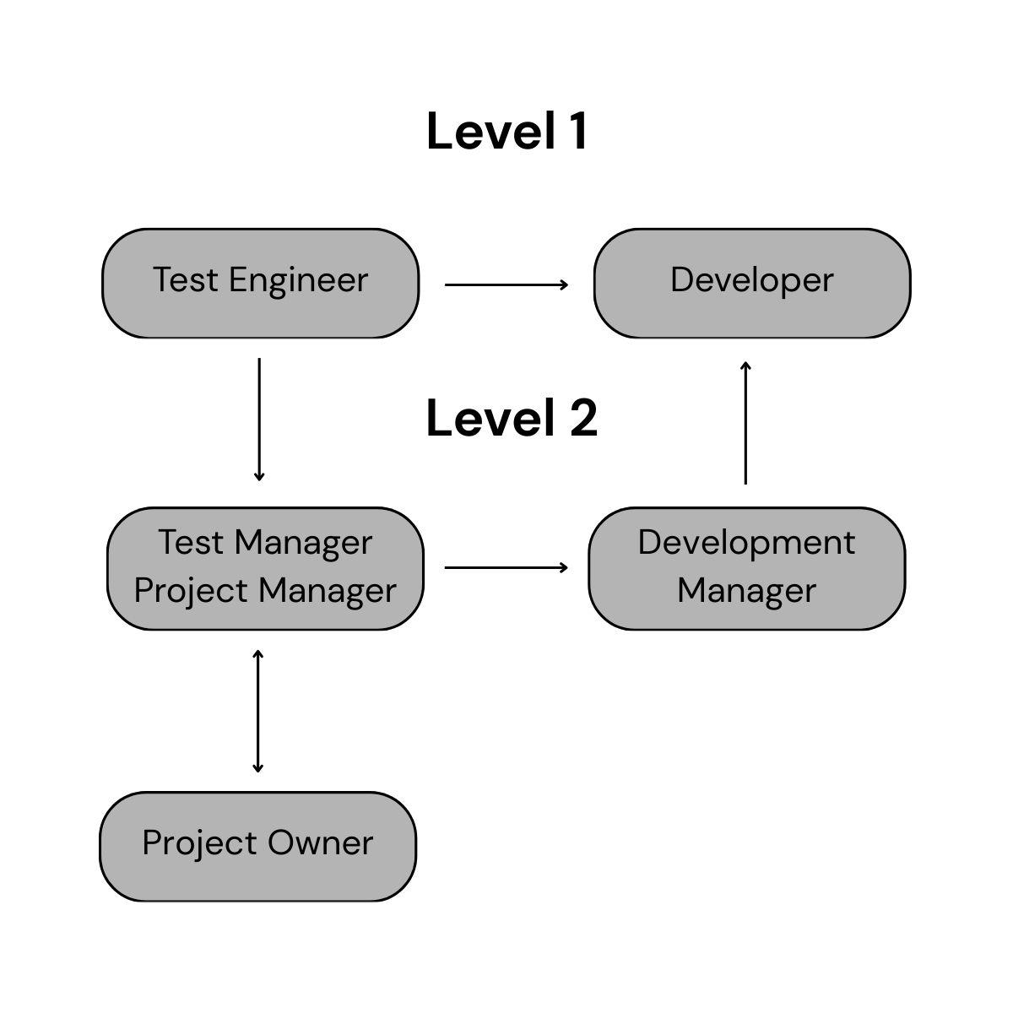

Measures and Metrics
At the Initiation Phase of the project the Test Team will publish a set of measures and metrics related to the test activities of their Planning & Analysis and Execution phases. The Test Plan also defines the milestone dates for key deliverables such as the Test Plan and these are metrics captured for ongoing statistical process analysis across successive projects.

Test Preparation
- Test Scenarios v. Number of Test Cases: Identify Scenarios like user login, product management, order placement, and delivery tracking.
- Test Cases Planned v. Ready for Execution: Monitor the preparation progress of test cases specific to the hardware’s services.
- Total time spent on Preparation v. Planned time: Track how long it takes to accomplish the preparation for test scenarios like verifying valid and invalid user login.

Test Execution and Progress
- Tests Cases Executed v. Test Cases Planned: Ensure coverage of scenarios like:
  - Adding items to cart
  - Processing delivery fee
- Test Cases Passed, Failed and Blocked: Focus on the performance and integration of API calls for login and delivery tracking.
- Test Cases Passed by Test Item / Test Requirements: Focus on core functions of the system like user login, edit personal information, and logout.
- Execution vs Planned Time: Monitor performance under different scenarios.

Bug Analysis
- Bugs raised and resolved: Focus on issues like user input validation
- Severity Distribution: Categorize bugs

‘Pass/Fail’ Criteria
Each Test Item will be assigned a Pass or Fail state dependant on two criteria:
- Zero severity Minimum Defects Open: Ensure there are no critical issues like system crashes or data breaches.
- 95% of Critical Test Cases Passed

The combination of both criteria will be used to recognise the Test Item can be declared Test Complete. However as this is a minimum level of quality that is believed achievable it’s recommended that where project timescales allow further testing and development should be conducted to raise the overall quality level.

Table of Issue Severity

Severity | Definition | Maximum Allowable
S1 | System crashes during order placement and checkout | 0
S2 | Inaccurate total amount due displayed. | 1
S3 | Minor UI error. | 3
S4 | Cosmetic problems: overlapping texts | 2
The total MAXIMUM number of issues recorded in Bugzilla / Bug Tracker that can remain in an Open & Unresolved state for the Test Item and be acceptable for release.

Table of Test Scenario Priority

Test Scenario | Definition | Minimum Pass Rate
P1 –Critical | Critical functions like order placement and checkout | 100%
P2 – Important | Order and Delivery Updates | 100%
P3 – Desirable | System theme | 70%
The MINIMUM set of Test Scenarios that must pass before the Test Item can be considered for release.

Unforeseen issues arising during the Test Phase may impact the agreed ‘Pass/Fail’ Criteria for the Test Item. Issues can be managed through review with the Test Team and the project authorities.

Suspension Criteria & Resumption Requirements
Testing of Test Items will be suspended if:

1a) Suspension criteria:
A Severity 1 issue is system crashes during order placement and checkout
1b) Resumption requirement:
The issue is fixed before the Test Item is returned to the Test Team for testing.

2a) Suspension criteria:
Major functionality issues are inaccurate stock updates and order placed.
2b) Resumption requirement:
The Test Team and PM must come to a conclusion on resolving the issue and agreeing a definition of the expected behaviour.

3a) Suspension criteria:
High failure rate is more than 20% of tests failed for order management
3b) Resumption requirement:
Test failure rate is below 20%

Test Deliverables
The following artefacts will be produced during the testing phase:

- Test Plan
Define the scope, approach, resources, and schedule of the functional testing activities.
- Test Schedule
Set schedules and timelines for functional testing of each feature

- Test Breakdown
Include scenarios for user roles (Customer, admin, driver).

- Test Cases
Write test cases for workflows like:
- User logs in the system.
- User adds the product to the cart.
- User searches for a product.
- User update delivery status.
- Periodic progress and metric update reports: Timely updates on bugs fixed.
- Bug Reporting:Highlight critical issues affecting the workflow.
- Test Summary Reports: Overview of test case scenarios.

Testing Tasks
The Testing Tasks that the Test Team will deliver cover the following scope:

- Fully In Scope: Functional and Regression Testing for Eliana Hardware Trading Inventory and Ordering System

- Partially in Scope: Integration testing for APIs like inventory system

- Out of Scope: Performance testing, Automated Regression, all forms of Non-Functional, Accessibility Compliance Testing, Security Testing, User Documentation Review.

Environmental and Infrastructure Needs
The following detail the environmental and infrastructure needs required for the testing of Eliana Hardware Trading Inventory and Ordering system.

Hardware.
- Integration Environment:
  - Development/Test Environment: Android and Laptop devices (various OS versions).
  - Pre-live/Staging Environment: High end system server

Software
- Bug Tracking Tool: Jira or similar.
- Test Case Management Tool: TestRail or similar
- Automation Tool: Selenium WebDriver

Infrastructure
- Stable network connections for all testing environments.

Test Repository
- http://...

Responsibility Matrix
The table below outlines the main responsibilities in brief for test activities:

Activity | Product Manager | Development  Manager | Test Manager | Test Engineer
Provision of Technical Documents | X | X
Test Planning and Estimation |  |  | X | X
Review and Sign off Test Plan | X | X | X
Testing Documentation |  |  | X | X
Test Preparation and Execution |  |  |  | X
Test Environment Set-up |  |  |  | X
Change Control of Test Environments |  |  | X | X
Provision of Unit Tested Test Items |  | X
Bug fixes and return to the Test Team for re-test |  | X
Product Change Control | X | X | X
Ongoing Test Reporting |  |  | X | X
Test Summary Reporting |  |  | X

Staffing and Training Needs
Staffing.
Staffing levels for the test activities will be:
- 1 Test Manager for the duration of test planning at 50% effort against plan.
- 2 Test Engineers for the duration of test execution at 100% effort against plan.

Training
- Familiarity with testing tools and frameworks.
- Hands-on training for functional testing and integrations.

Schedules and Resource Plans
Team Plan.
Maintain task assignments and time reviews to monitor progress and align to test execution timelines.

Test Schedule.
The Test Schedule for the Release will be located within <Document Store Name> at: http://

Risks and Contingencies

 | Risk | Mitigation Strategy | Impact
1 | Delays in implementing key features like checkout, inventory updates, or delivery tracking | Regular progress tracking with Agile sprints; prioritize critical features for early testing | High
2 | Defects in inventory or ordering functionality affecting stock accuracy | Maintain clear communication between developers and QA; implement defect tracking and defined SLA for fixes | High
3 | Lack of domain knowledge on hardware store processes among testers | Collaborate with store staff and inventory managers to provide training and guidance during testing | Medium
4 | Missing or incomplete product information affecting testing | Conduct stakeholder review sessions before testing; maintain clear documentation of product and supplier data | Low
5 | Integration issues between inventory, ordering, and delivery modules | Schedule frequent system integration tests; use mock APIs for dependent modules to reduce cascading failures | Medium

Approvals
The following people are required to approve the Test Strategy

Approval By | Approval
Test Manager | Julianne Harieth Buenafe
The Test Department Manager | Sabina Allyanah Hernandez
Product Owner | Mr. Eulogio Holgado Bonilla Jr.,
Development Manager | Hannah Marie Mendoza
Project Manager | Julianne Harieth Buenafe

